**Name: Kalyani Pardeshi**

Roll No:750 G3

PRN No:202201040114

Practical no :- 5

The Code is :

Extracting the file:- import pandas as pd

import matplotlib.pyplot as plt df=pd.read_csv("testmarks1.csv") print(df)

RollNo EDS SON DT ET 0 801 43.05 27.79 28.70 27.79

1 802 43.47 28.52 28.98 27.89

2 803 42.24 28.16 28.16 25.63

3 804 39.24 26.16 26.16 26.16

4 805 40.90 26.03 27.27 25.65

5 806 39.47 26.31 26.31 25.21

6 807 41.68 25.63 27.79 25.46

7 808 42.19 27.61 28.13 26.21

8 809 44.75 28.35 29.83 28.21

9 810 46.95 28.88 31.30 28.53

Plotting Line Graph:- import numpy as np import pandas as pd

import matplotlib.pyplot as plt df=pd.read_csv("testmarks1.csv")

Plot 1: xpoints=np.array(df['RollNo'])ypoints=np.array(df['EDS']) plt.subplot(1,1,1)

plt.plot(xpoints,ypoints) plt.title('EDS')

plt.grid() plt.show()

Plot 2:

xp=np.array(df['RollNo'])yp=np.array(df['SON']) plt.subplot(2,1,2) plt.plot(xp,yp)

plt.title('SON') plt.grid() plt.show()

Plot 3: xp1=np.array(df['RollNo'])yp1=np.array(df['DT']) plt.subplot(3,1,3)

plt.plot(xp1,yp1) plt.title('DT') plt.show()

Plot 4:

xp2=np.array(df['RollNo']) yp2=np.array(df['ET']

plt.subplot(4,1,4) plt.plot(xp2,yp2) plt.title('ET')

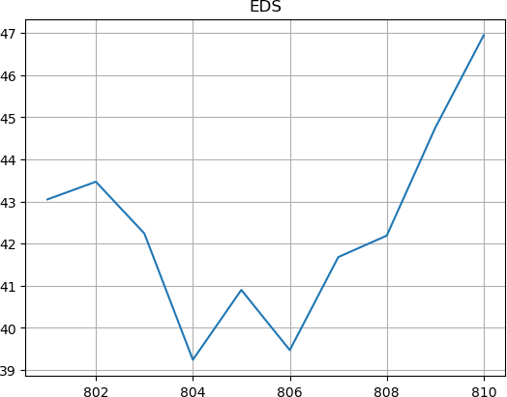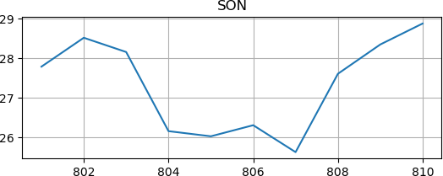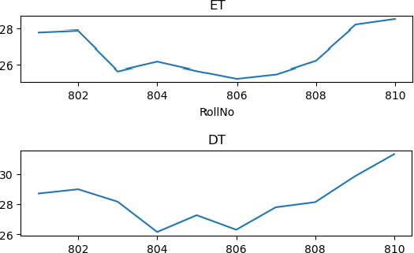plt.xlabel('RollNo') plt.show()

import numpy as np import pandas as pd

import matplotlib.pyplot as plt

df=pd.read_csv("testmarks1.csv") Plot 1: xpoints=np.array(df['RollNo']) ypoints=np.array(df['EDS']) plt.subplot(1,1,1) plt.bar(xpoints,ypoints) plt.title('EDS')

plt.show()

Plot 2: xp=np.array(df['RollNo']) yp=np.array(df['SON']) plt.subplot(2,1,2) plt.bar(xp,yp) plt.title('SON') plt.show()

Plot 3: xp1=np.array(df['RollNo']) yp1=np.array(df['DT']) plt.subplot(3,1,3) plt.bar(xp1,yp1) plt.title('DT')

plt.show()

Plot 4: xp2=np.array(df['RollNo']) yp2=np.array(df['ET']) plt.subplot(4,1,4) plt.bar(xp2,yp2) plt.title('ET')

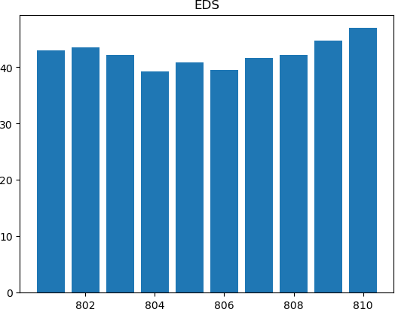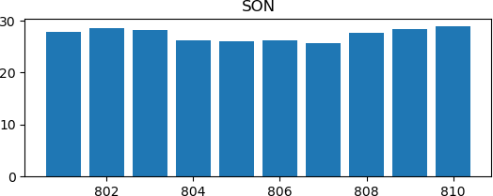plt.xlabel('RollNo') plt.show()

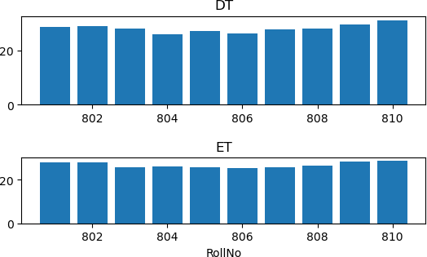

Plotting the line plot:-

df.plot(x='RollNo', y=['EDS', 'SON', 'DT', 'ET'])

plt.xlabel('Roll Number') plt.ylabel('Values') plt.title('Line Plot')

plt.legend(['EDS', 'SON', 'DT', 'ET'])

plt.show()

